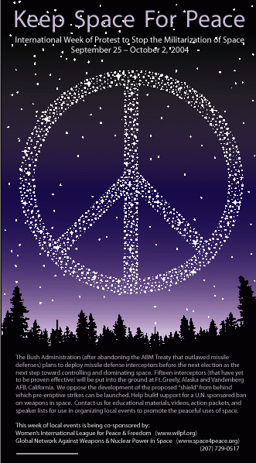
NO to Star Wars
Minto park (Elgin/Cooper) to
Parliament Hill
Creative peaceful action
including… YOU!!!
stopBMD@yahoo.ca tel: 565-5959
KEEP CANADA OUT OF
MISSILE DEFENCE
Canadian Peace Alliance www.acp-cpa.ca

CIRCUS Oct 2 @ 1 PM
NO to Star Wars
Minto park (Elgin/Cooper) to
Parliament Hill
Creative peaceful action
including… YOU!!!
stopBMD@yahoo.ca tel: 565-5959
KEEP CANADA OUT OF
MISSILE DEFENCE
Canadian Peace Alliance www.acp-cpa.ca

CIRCUS Oct 2 @ 1 PM
NO to Star Wars
Minto park (Elgin/Cooper) to
Parliament Hill
Creative peaceful action
including… YOU!!!
stopBMD@yahoo.ca tel: 565-5959
KEEP CANADA OUT OF
MISSILE DEFENCE
Canadian Peace Alliance www.acp-cpa.ca

CIRCUS Oct 2 @ 1 PM
NO to Star Wars
Minto park (Elgin/Cooper) to
Parliament Hill
Creative peaceful action
including… YOU!!!
stopBMD@yahoo.ca tel: 565-5959
KEEP CANADA OUT OF
MISSILE DEFENCE
Canadian Peace Alliance www.acp-cpa.ca

CIRCUS Oct 2 @ 1 PM
NO to Star Wars
Minto park (Elgin/Cooper) to
Parliament Hill
Creative peaceful action
including… YOU!!!
stopBMD@yahoo.ca tel: 565-5959
KEEP CANADA OUT OF
MISSILE DEFENCE
Canadian Peace Alliance www.acp-cpa.ca

CIRCUS Oct 2 @ 1 PM
NO to Star Wars
Minto park (Elgin/Cooper) to
Parliament Hill
Creative peaceful action
including… YOU!!!
stopBMD@yahoo.ca tel: 565-5959
KEEP CANADA OUT OF
MISSILE DEFENCE
Canadian Peace Alliance www.acp-cpa.ca

CIRCUS Oct 2 @ 1 PM
NO to Star Wars
Minto park (Elgin/Cooper) to
Parliament Hill
Creative peaceful action
including… YOU!!!
stopBMD@yahoo.ca tel: 565-5959
KEEP CANADA OUT OF
MISSILE DEFENCE
Canadian Peace Alliance www.acp-cpa.ca

CIRCUS Oct 2 @ 1 PM
NO to Star Wars
Minto park (Elgin/Cooper) to
Parliament Hill
Creative peaceful action
including… YOU!!!
stopBMD@yahoo.ca tel: 565-5959
KEEP CANADA OUT OF
MISSILE DEFENCE
Canadian Peace Alliance www.acp-cpa.ca

CIRCUS Oct 2 @ 1 PM
NO to Star Wars
Minto park (Elgin/Cooper) to
Parliament Hill
Creative peaceful action
including… YOU!!!
stopBMD@yahoo.ca tel: 565-5959
KEEP CANADA OUT OF
MISSILE DEFENCE
Canadian Peace Alliance www.acp-cpa.ca

CIRCUS Oct 2 @ 1 PM
NO to Star Wars
Minto park (Elgin/Cooper) to
Parliament Hill
Creative peaceful action
including… YOU!!!
stopBMD@yahoo.ca tel: 565-5959
KEEP CANADA OUT OF
MISSILE DEFENCE
Canadian Peace Alliance www.acp-cpa.ca

CIRCUS Oct 2 @ 1 PM

