GLOBAL DAY AGAINST THE WAR ON IRAQ

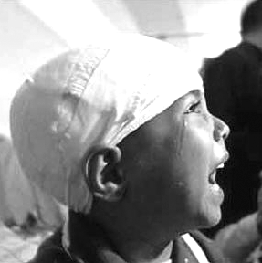

PARLIAMENT HILL SATURDAY APRIL 12, 2003 1:00PM
Innocent Iraqis are being terrorized, traumatized and murdered. Come to the Parliament Hill to say NO, again and again, to this illegal and sinister war. The pro-war lobby is increasing its pressure to change position of the government of Canada. Do not let them succeed. Contain George Bush. Your participation could save precious Iraqi lives. Do not leave anyone home. Contact info: futurehint@yahoo.com or call 266-6314.
ORGANISED BY COMMITTEE FOR PEACE IN IRAQ & Rassemblement Outaouais Contre la Guerre (ROCG)
http://www.nowar-paix.ca/ http://iquebec.ifrance.com/rocg/

